SQL - Question -4

Consider the Employee table below.

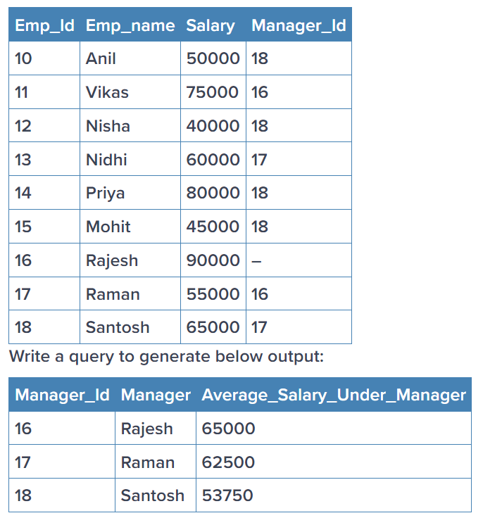

Answer –

SELECT m.Manager_Id, m.Emp_name AS Manager, AVG(e.Salary) AS Average_Salary_Under_Manager

FROM Employee e

LEFT JOIN Employee m ON e.Manager_Id = m.Emp_ID

GROUP BY m.Manager_Id, m.Emp_name

ORDER BY m.Manager_Id;